|  |  |  |  |  |  |
| --- | --- | --- | --- | --- | --- |
| **Patient Information** | | | | | |
| Patient Name (Last, First, MI) | Sex | Marital Status | Date of Birth | | Social Security No. |
| Street Address | City, State, Zip | | | | Home Phone |
| Employer | Employer Address | | | | Work Phone |
| Email Address | | Please check here if you would like to receive reminders and other communications by text  Cell Phone: | | | |
| **Emergency Contact** | | | | | |
|  | | | | | |
| Name | Relation to Patient | | | Phone Number | |
|  | | | | | |
| PLEASE PROVIDE STAFF WITH A PHOTO ID AND YOUR INSURANCE CARD SO THAT WE MAY PUT A COPY IN YOUR CHART. | | | | | |

**Name:___________________________________________Date of Birth ______________Age: _______**

**PREMIER HAS RECEIVED A REFERRAL FROM YOUR MD FOR TREATMENT OF:**

|  |
| --- |
|  |

Are you currently taking any of the following medications:

Pain Yes No Anti Inflammatories Yes No Muscle Relaxants Yes No

List Any Other Medication you are taking**:**

**Yes/No Yes/No**

|  |  |  |
| --- | --- | --- |
| Do you have a PACEMAKER | History of Cancer/tumors | High blood pressure |
| Seizures/nerve disorder | Stroke (CVA) | Joint replacement ? |
| Are you pregnant? | Heart disease | Diabetes |
| Dizziness-blackouts | Gout | Auto-Immunity disorders |
| Increased thirst/ hunger | Do you have 24 hr pain? | Do you awaken from pain? |
| Night/Sleep Disturbances | Irregular headaches | None Reported |
|  |  |  |
| *Do you smoke?  **How Many Daily? Weekly?** | |  |
| Do you drink? **How Many Daily? Weekly?** | |  |

**\*PLEASE BE ADVISED THAT SMOKING MAY DELAY YOUR HEALING PROCESS.**

How did your injury occur?

Have you been hospitalized for the current problem? Yes No

Have you had surgery for the current problem? Yes No

Have you had any other previous surgeries:Yes No

What is your occupation/job title**? ________________________________________________________**

Are you currently working**?** Yes No Full Duty Light Duty Full Time  Part Time

Have you attended physical therapy for the current injury: Yes No How Long? ____________

Where: _______________________________________________________________________________

Please check any of the following that you have consulted with for your current injury:

Pain Specialist  Orthopedic MD  Chiropractor  Lawyer

Check any that increase your pain:

|  |  |  |
| --- | --- | --- |
| Sitting | Standing | Walking |
| Reaching | Kneeling | Squatting |
| Bending | Dressing | Daily Activities |
| Driving | Sleeping | Pushing |
| Pulling | Exercise | Carrying |
| Lifting | Stooping | Ascending Stairs |
| Descending Stairs |  |  |

Date your pain began?_________________________

Have you had any of the following performed?

X-rays Yes No CT scan Yes No

EMG/NGC Yes No MRI Yes No

Arthrogram Yes No Injections Yes No

Based on the drawing below please indicate your pain level: **_____________**

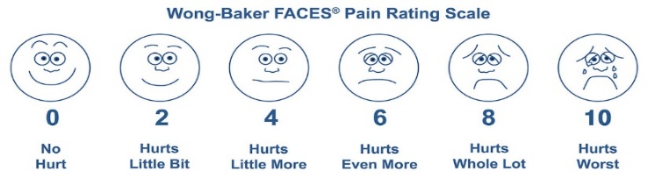

Check any of the following that describe your pain: Sharp Numb/Tingling Dull/Aching Burning

Check any of the following that help alleviate your pain: Medication Rest Sleep

Do you have headaches? Yes No

Frequency of headaches: 1-2 weekly 2-4 weekly 4-5 weekly Daily

Aggravating Symptoms: Light Sound Noise

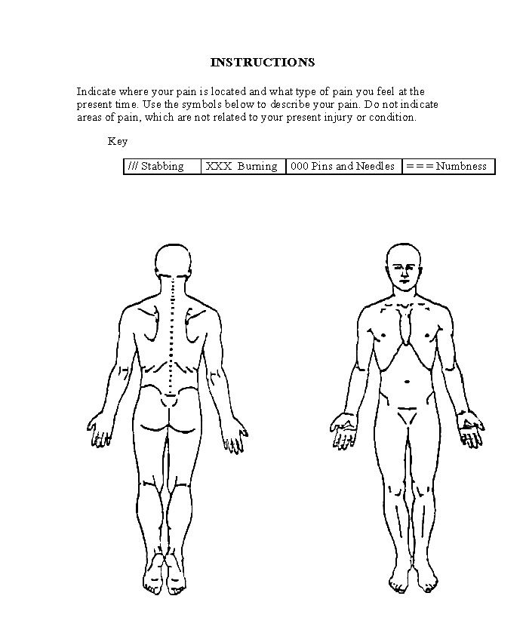

**CONSENT FOR TREATMENT:**

I hereby give my permission for Premier Comprehensive Physical Therapy Center Inc. to render treatment to me/my dependent. I understand that I will be given all available pertinent information prior to the treatment being rendered. I will be given the opportunity to ask questions and to have them answered to my satisfaction. I understand that I may decline treatment at any time.

____________________________ _________

SIGNATURE DATE

**CONSENT TO RELEASE/OBTAIN MEDICAL INFORMATION:**

Permission is hereby granted to Premier Comprehensive Physical Therapy Center Inc. to release information to my insurance company, employer, attorney, workers compensation carrier, physician/facility referred to for further treatment and/or my referring/family physician. Permission is hereby granted to any facility where I have previously been treated to release medical records to Premier Comprehensive Physical Therapy Center Inc.

____________________________ _________

SIGNATURE DATE

**AUTHORIZATION FOR PAYMENT OF BENEFITS:**

I authorize Premier Comprehensive Physical Therapy Center Inc. to bill my health insurance for services rendered. All payments received will be applied to my balance. I will be responsible for all co-pays/co-insurance and deductibles that may apply. Although Premier Comprehensive Physical Therapy Center Inc. will help verify and assist me in understanding my benefits, it is ultimately my responsibility and I will not hold Premier Comprehensive Physical Therapy Center Inc. responsible for any misinterpretation of insurance benefits. I understand that any charges not paid by my insurance company are my responsibility, and are due and payable by me.

_____________________________ _________

SIGNATURE DATE

**MEDICARE PATIENTS ONLY:**

I authorize payment of Medicare benefits to Premier Comprehensive Physical Therapy Center Inc. for services rendered, and I authorize the release of medical information to CMS (Centers for Medicare and Medicaid Services)

and/or its agents.

_____________________________ _________

SIGNATURE DATE